Year 5 – Home Learning
Hi Year 5,
Hope that you are well.
Please see below the list of activities that you can be doing whilst we are not at school –keep safe and we look forward to seeing you at school soon!
Mr Bannister and Mrs Kaur
Maths – TTRS
Continue to log onto Times Tables Rock Stars and keep your times tables knowledge sharp!

Maths – Multiplication – 4-digit x 1digit
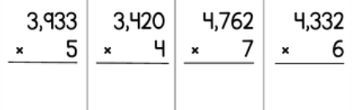
Maths – Multiplication – 3-digit x 2 digit – remember ‘zero the hero!’
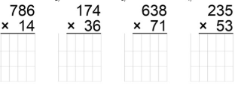

Writing – Year 5 / 6 spellings
Review and focus on the Year 5 / 6 spellings. Have a go at LCWC and test yourself on words you’re not confident with!
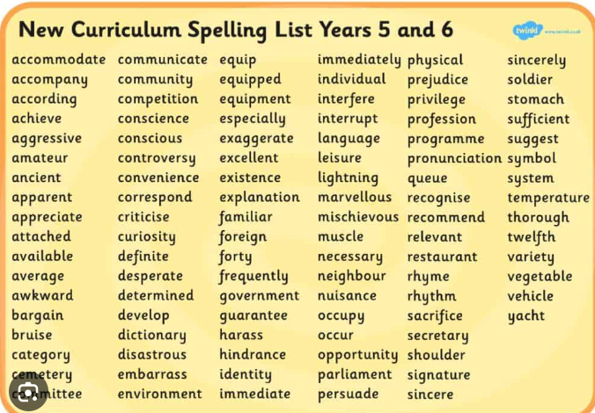
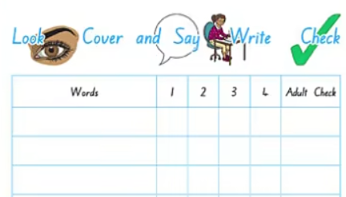
Writing – Instructions Text - Can you complete your set of instructions on ‘How to survive an alien invasion’? What will you change from your original equipment list? Will you include a quote from the Prime Minister or University Lecturer?
You must remember your title, introductory paragraph, equipment list and method… not forgetting your illustrations!
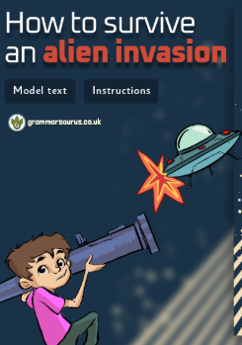
Reading – Accelerated Reader
Continue to read your reading books so when we return to school you can complete your quizzes! Remember to get your reading diaries signed too!

Finished your book? Complete a book review about the book you have read or another book you enjoyed reading!

Writing - SPaG – Can you write out and answer the following questions?
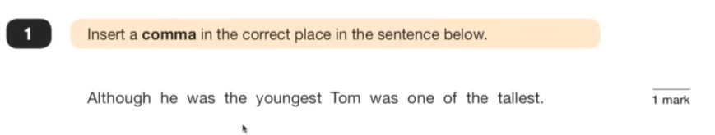
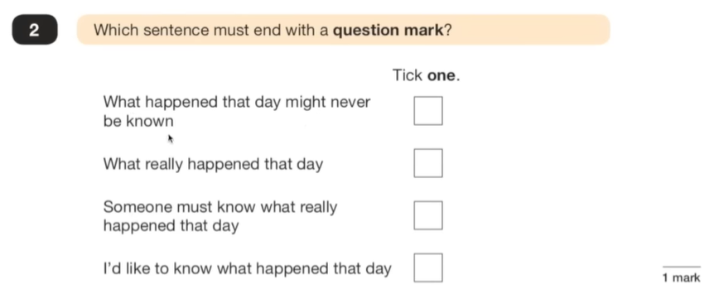
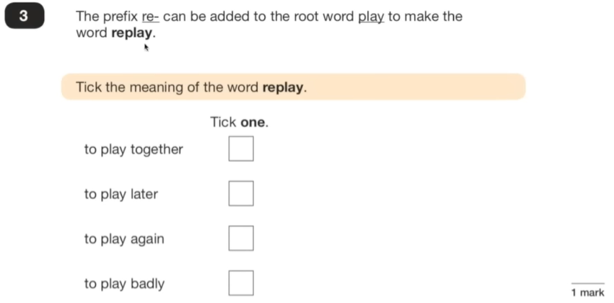
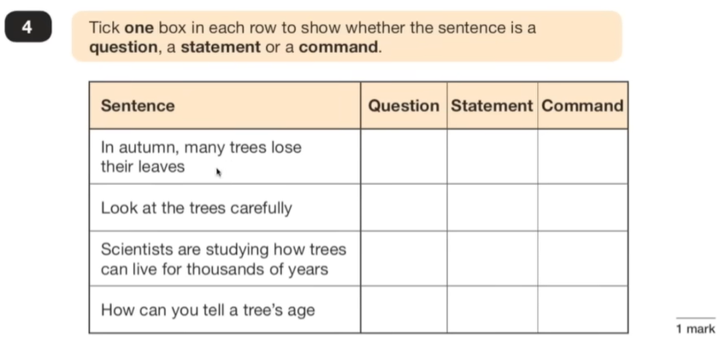
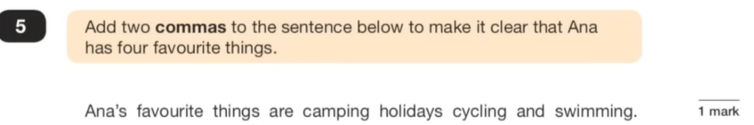
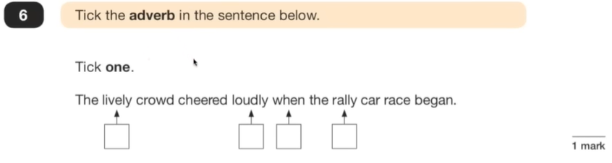
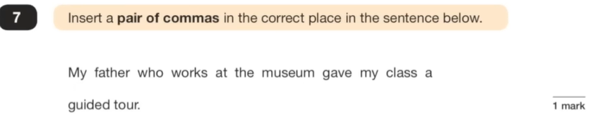
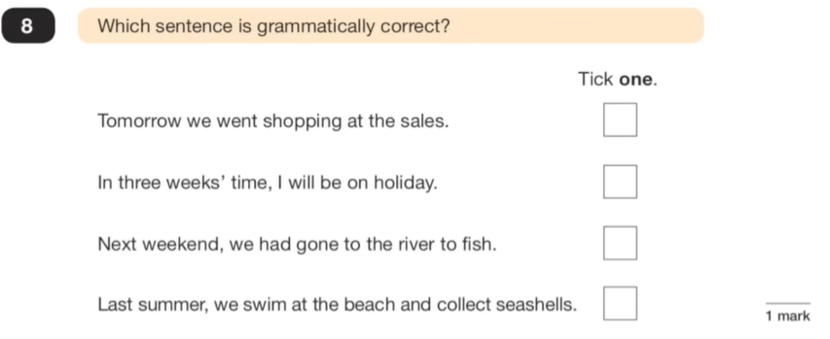
Computing – Excel – Can you log into J2E and then onto J2E Office and Spreadsheets. Can you remember the formulae from last week (=4*2)? Have a go at another multiplication table!


