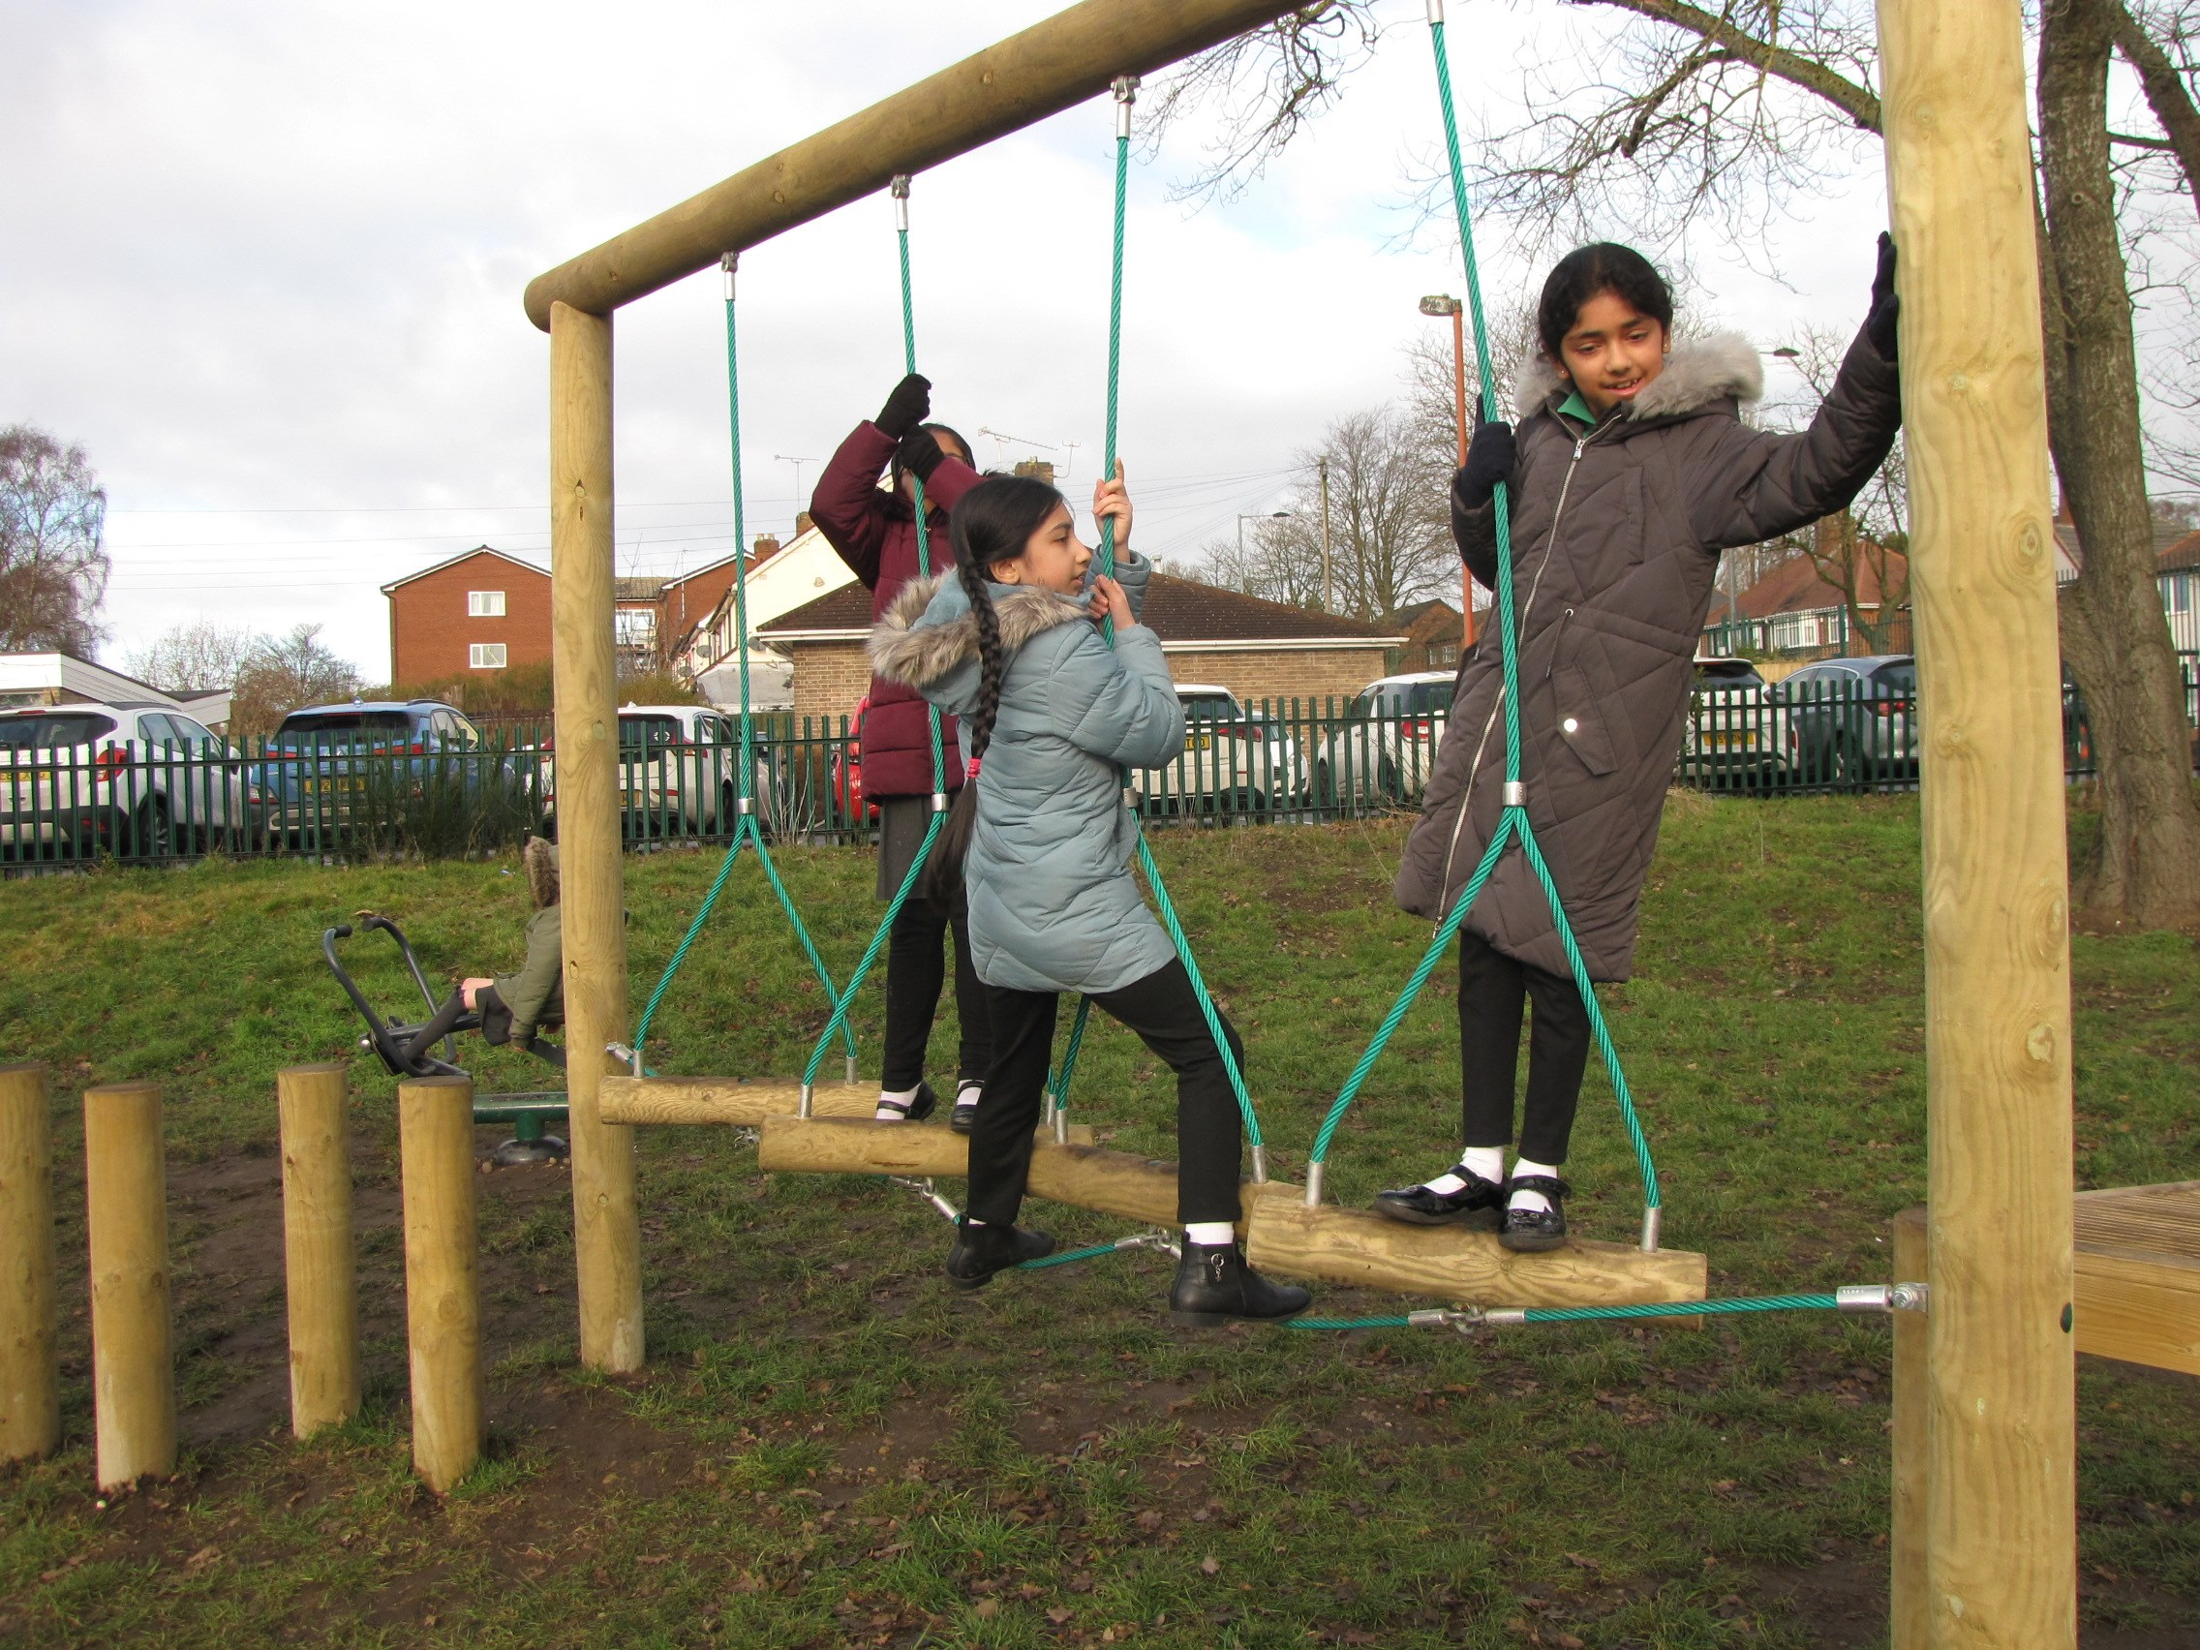
School Prospectus 2023

Working in Partnership for Success
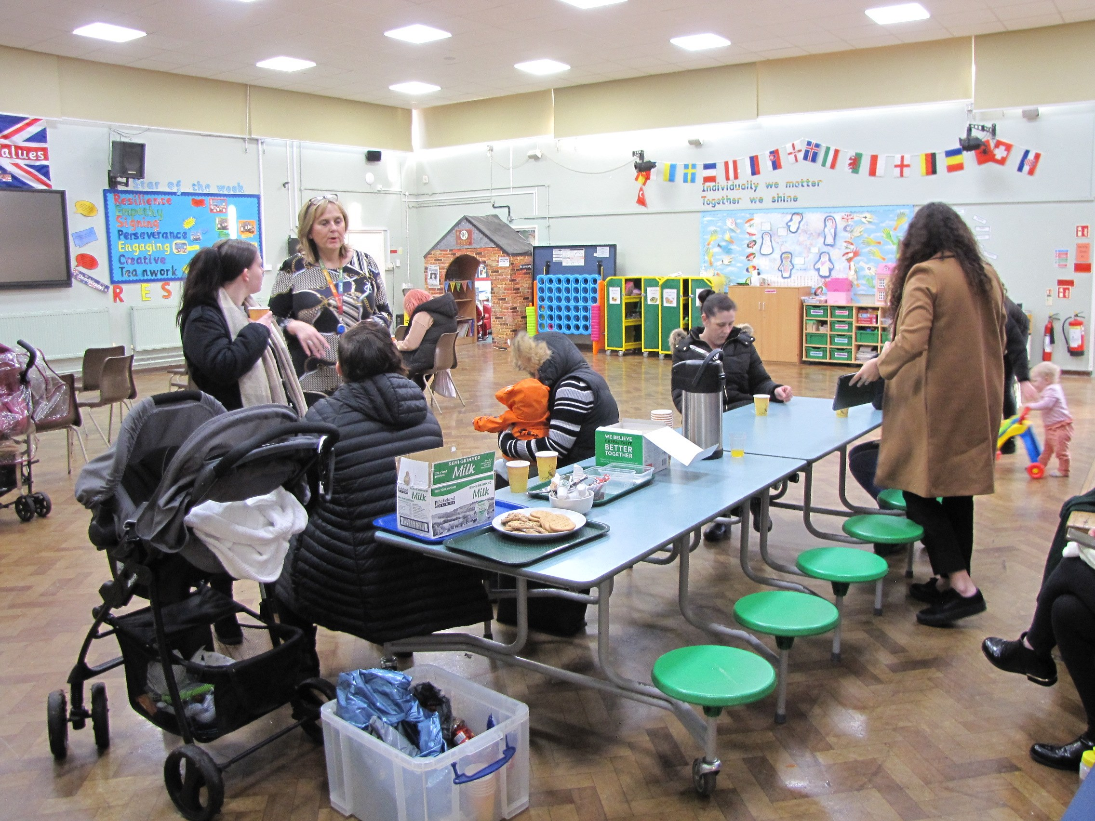
The learning environment
Our school will:
- Provide your child with a high standard of education, implemented by rigorous national guidelines, with a balanced curriculum.
- Ensure that our learning environment is stimulating and challenging.
- Celebrate your child's academic and personal achievements.
- Provide the scaffolding needed to enable your child to achieve their full potential.
- Care for your child's safety and well-being by observation and listening.
A Healthy, Happy Community
Our School will:
- Teach your child to develop a positive attitude to one another, regardless of gender, race, culture, belief, values, age and need.
- Encourage your child to become an active member within our community and help them to see that they can have an impact on the world around them.
- Regularly meet with you to communicate the progress of your child, celebrating their strengths and explaining how we can support them in their areas of development.
- Provide information to you about our school, including relevant policies, meetings, workshops, activities, newsletters and open days.
- Be very happy to welcome you if you would like to contribute to our school's broader curriculum. We recognise that the community of Hawthorn holds a wealth of talent, experience, diversity and enthusiasm that our school could benefit richly from.
Homework
The school will:
- Set differentiated and achievable homework to extend the curriculum and provide the opportunity for independent learning. Clear information will be provided so that you will be able to help your child if required.
- Provide information and helpful training sessions for you that will give you confidence to support your child.

Policies and Term Dates
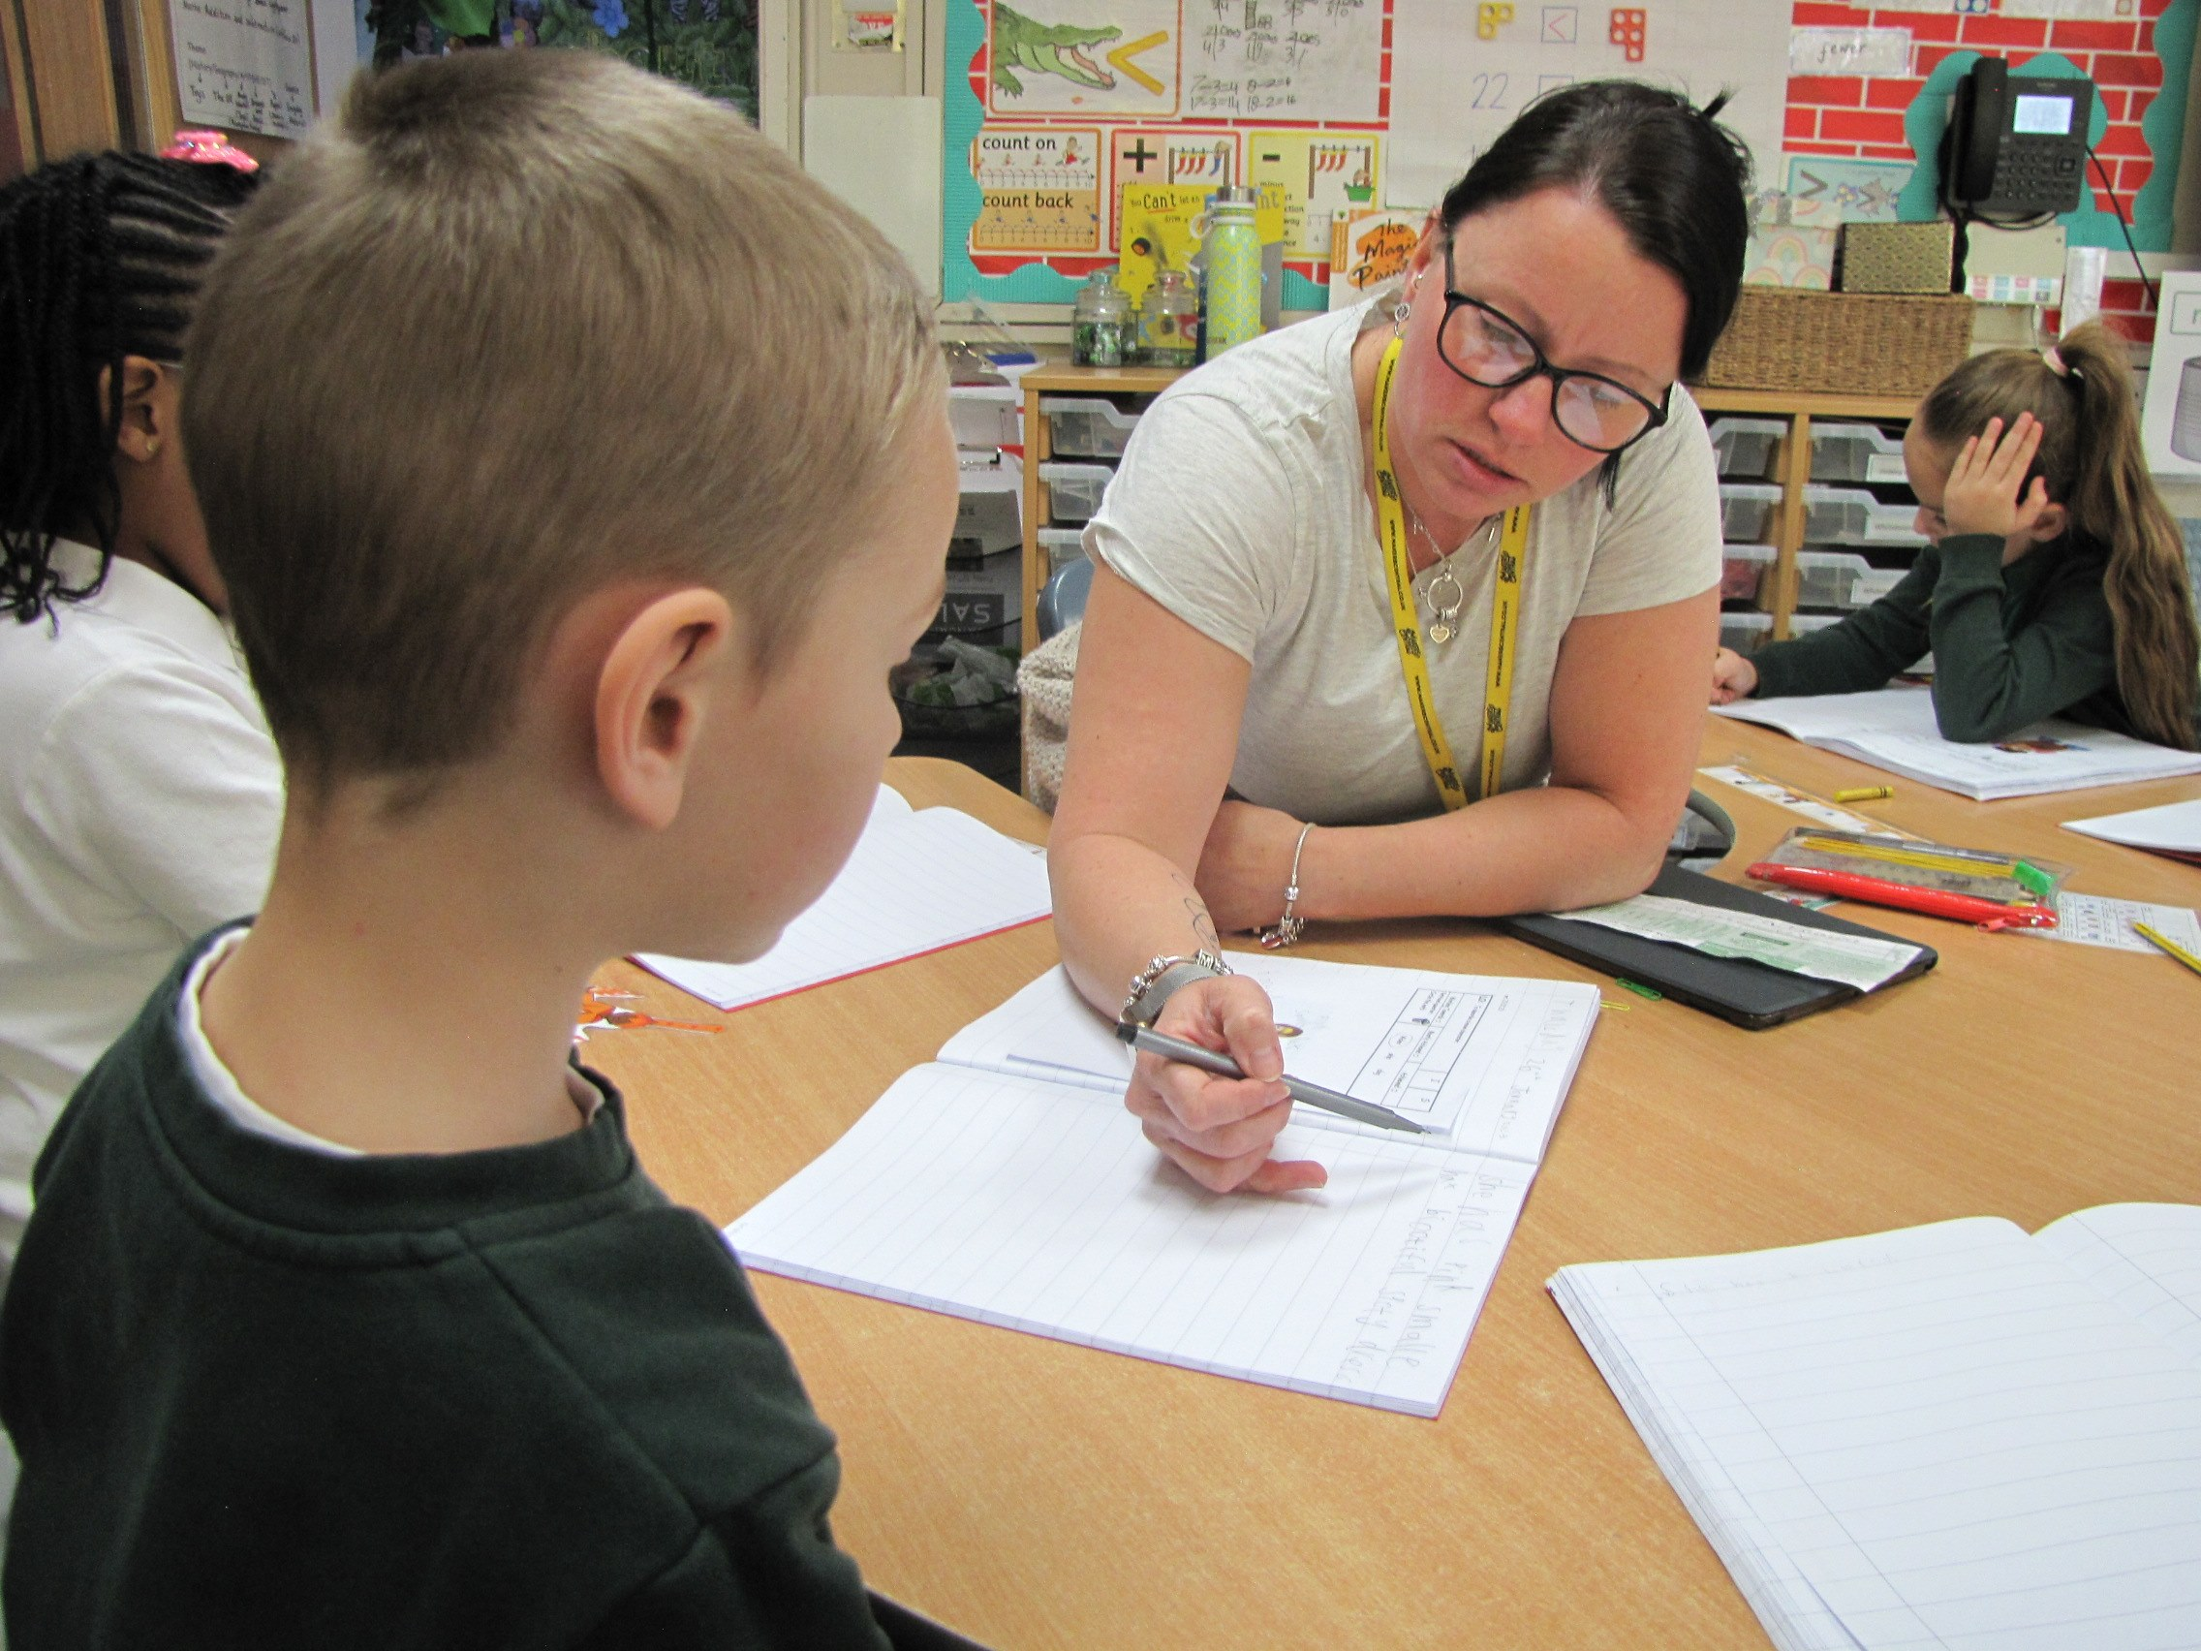
For policies and term dates please visit our website Hawthorn Primary

Our School Team
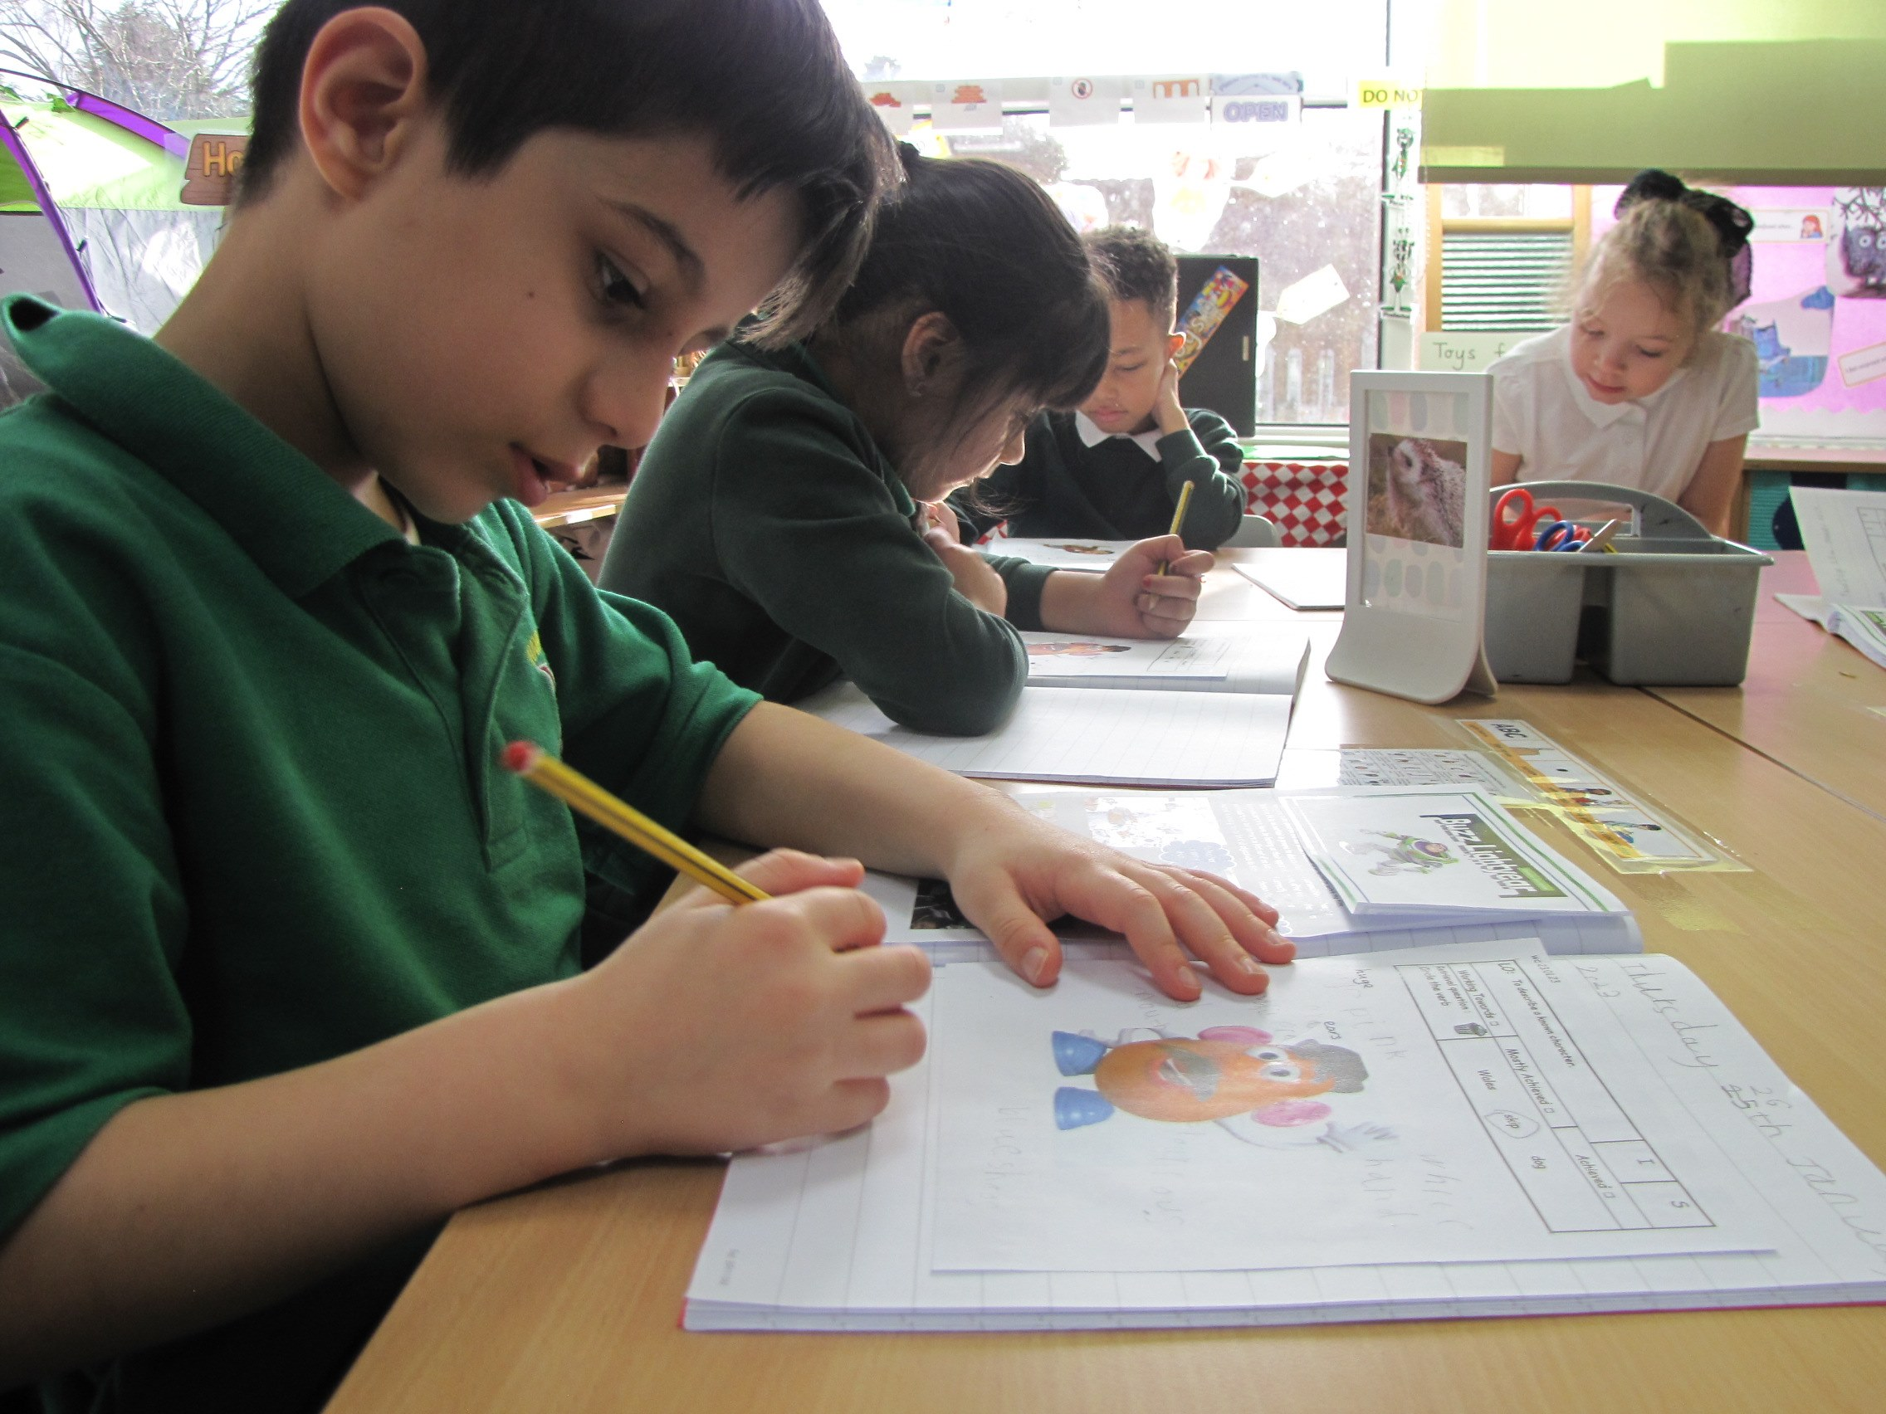
Mrs Sam Abraham: Headteacher
Mrs Felicity Cook: Deputy Headteacher, Special Educational Needs & Disability Co-Ordinator (SENDco)
Mrs Clare Maksymczuk: Early Years Lead and Reception Teacher
Ms Dawn Phillips: Year 1 teacher
Mr Joe Bannister: Year 2 teacher
Mr Oliver Davies and Mrs Helen Goodwin: Year 3 teacher
Mr Tame: Year 4 teacher
Mr Anthony Robinson: Year 5 teacher
Miss Alix Bingham and Mrs Vicky Gore: Year 6 teacher
Mrs Vanessa Phillips: Hearing resource base teacher
Miss Sade Rowaiye: SEND teacher
Miss Laura Parry: SEND teacher

Pastoral Team with responsibility for attendance: Miss Aisha Zentani, Miss Eleanor Barker and Miss James.

Chair of Governors Mr Chris Pritchard Address

school email: enquiry@hawthorn.bham.sch.uk
School website www.hawthornprimaryschool.co.uk

Our Governing Body
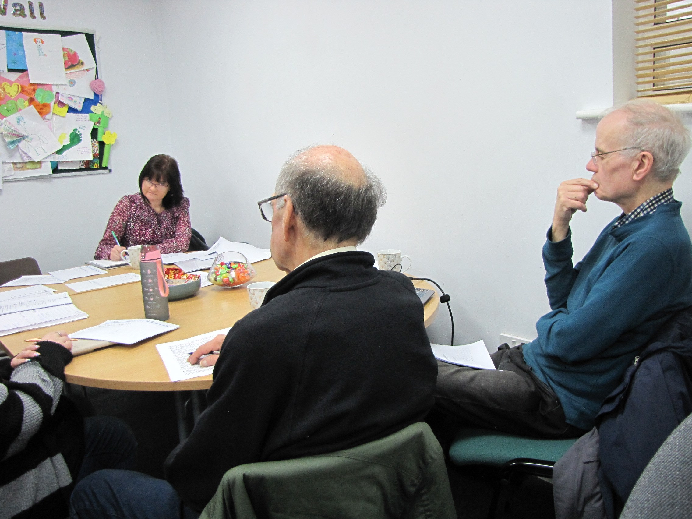
The role of a Governor within a primary school is a serious yet extremely rewarding duty. They play an essential role in setting the strategic direction for the school and holding its leadership to account.
The Governing Body has responsibility for:
• delivery of the curriculum
• care and safety of the children and staff
• appointment of staff
• management of the budget
• maintenance of the building.
The full Governing Body meets at least three times a year, but a lot of work is undertaken in various committees: The Governing Body meets twice a term.

What are our school times?

All children are encouraged to come into school from 8:45am. Children are encouraged to come into school from this time to have a calm and settled start to their school day. They also start learning from 8:45am with interventions and focused Maths and English activities.
The register is taken at 8:55am and it is after this time that a 'late' mark will be recorded if your child is not in school by this time. Being in school on time on a regular basis, is incredibly important. We work hard as a school to support your child's regular attendance and punctuality.

Breakfast Club

We have a Breakfast Club on the school premises that opens at 7:45am. This is an excellent opportunity for children to enjoy a great start to the day. We provide cereal, toast, juice or milk, followed by activities such as board games and crafts. All that we ask is for a nominal cost of £1 per day. Please contact the school office if you would like to book your child's place.

Uniform
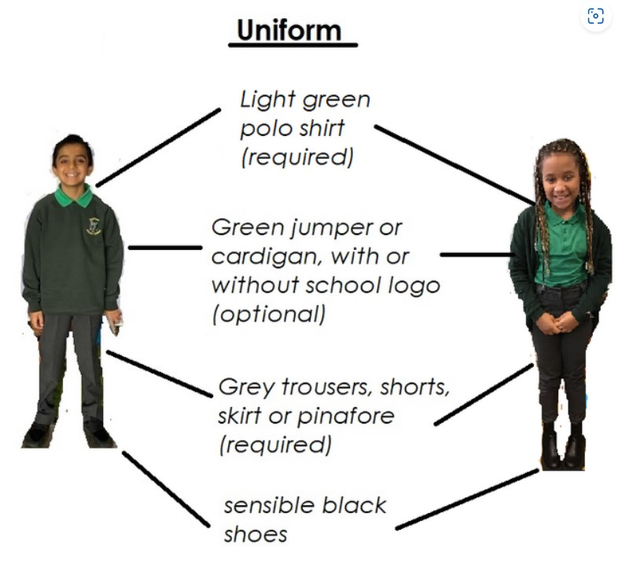
Children at Hawthorn wear school uniform as we believe it provides a sense of identity and pride as well as a 'level playing field' for all children. This applies to the Hawthorn School Bags and water bottles that are provided free of charge. We kindly request that no other bags or bottles are brought into school. If bags and bottles need to be replaced this can be done through the school office. Please see our school website for further details of our school uniform policy, including what children are expected to wear for P.E.

School Lunches
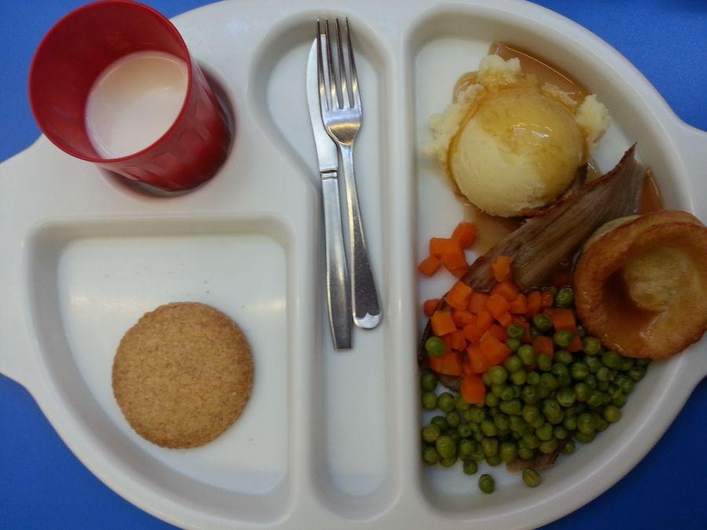
Parents can buy school meals at a cost, or children can bring in a packed lunch to eat during lunchtime. We operate a healthy easting policy at our school and therefore children are not allowed sweets or fizzy drinks in their packed lunches.
Free School Meals
Al children in Early Years and Year 1-2, may have free school meals, To qualify for a free school from Year 3 onwards, parents must be in receipt of Income Support, Income Based Job Seekers Allowance, Child Tax Credit or support under part IV of the immigration and Asylum ACT 1999.
Drinks and Snacks
Only healthy snacks are allowed at morning breaktime. Free fruit is provided for children from Nursery to Year 2. From Year 3 onwards, children may bring in a healthy snack from home. Water is available at all times throughout the school day.

Absence
At Hawthorn we aim to provide a safe and ha[[y environment where children feel successful and enjoy all aspects of school. Safe, happy and successful children are children who want to be in school everyday-100% attendance is extremely important for the best academic and social progress to be made. 100% attendance is defined as no absenses, either of an authorised or unauthorised nature, with the exception of a visit to a hospital or clinic during the school day.

Each week, classes with the overall highest attendance are presented with a certificate. Children who gain 98% or above each term receive a certificate at th end of each year. Bronze, Silver and Gold medals are rewarded.

Holidays
Legislation and Local Authority Guidelines state that, as a school, we are not permitted to authorised any leave of absence during term time.
Allowances will, however be made for exceptional circumstances. Exceptional circumstances are defined as;
- The death of the parent/carer or subling of the child
- Life threatening or critical illness of parent or sibling of the child
- Parent/Carer recuperation and convalescences from critical illness or surgery
- Leave for armed forces personnel who are prevented to take their leave at any other time

Our Attendance and Punctuality Policy is also available on request from the school office, and can also be found on the school website.

Seeking Permission
We will always seek your permission if any activity takes place after school. If we are playing a sport at another venue we will aim to arrange transport for all pupils which may include the school's minibus. We will always inform you of the arrangements of any educational visits in school through our app and letters home.

Jewellery and Hair Styles

Only watches, simple ear studs and Med-alert bracelets are permitted in school. All studs must be removed prior to any physical activity.
Hair colour should be natural and not extreme, and children must not have hairstyles fitting to the following descriptions:
- Lines shaved into the hair
- Patterns shaved into the hair
- Hairstyles which are extreme. This includes bright hair dye.

Collective Worship

Collective worship offers schools the chance to explore and understand the values at the heart of their ethos. From forgiveness and humility to gratitude and justice, collective worship gives pupils a space and time to reflect. As part off a school's routine, collective worship provides a shared language of values to build a close-knit cohesive community. Whether in times of crisis or celebration, the time set aside in the school day for reflection provides everyone with the opportunity to gather and support one another as a community.

Home Learning

Home learning is part of a effective partnership between the school and parents in pursuing the aims of the school. It extends learning by consolidating and reinforcing skills and understanding especially in English through additional reading, phonics and spelling and in Maths through extension of classroom learning and practice of number facts.

Code of Conduct/UNICEF Children's Rights

Our school motto of 'Individually We Matter, Together We Shine' is embodied in all we do at Hawthorn.
We have a Code of Conduct for pupils and staff which simply promotes our ethos of care and respect. Alongside this, as a school promoting the UNICEF Rights of the Child, we have a summary of the Rights; that reflect the aspects of our code.
We are proud to have gained the Gold-Rights Respecting Award inr ecognition of our commitment to the Rights Respecting Agenda.

Special Educational Needs and Disabilities
It is estimated that 20% of all school aged pupils will have some sort of learning difficulty during their school life, so please do not be alarmed if your child's class teacher informs you that your child has been placed on the Special Need Register, In doing this, your child will be entitled to extra support from either the Inclusion Leader and/or a member of the school staff. Some children receiving extra intervention will have individual targets, shared termly with parents/carers, through face to face meetings.
Your views as a parent are extremely important and you are encouraged to attend school regularly to discuss your child's progress. The Inclusion Leader is available by appointment to discuss any issues or concerns you may have,

Access
Children with a physical disability are fully supported in accessing the school environment. School has a lift in order for children to access upstairs classrooms as well a ramps around school for wheelchair access.
Hearing Resource Base
The Hearing Resource Base provides for the special educational needs of primary age children with impaired hearing. We believe this provision enhances our school and the experiences of everyone within the school community. Children are drawn from all over the city and brought into school each day by taxi. There are 10 spaces available in our resource base provision from Reception to Year 6.

Charging Policy
We recognise that additional activities, including clubs, visits and residential experiences can make a valuable contribution towards pupils' personal and social education. From time to time, the school Governing Body may invite parents to make voluntary contributions for the benefit of the school or in support of any such activity, whether during or outside school hours. Any contributions sought will be entirely voluntary and pupils will not be treated differently according to whether or not their parents make a contribution in response to any invitation. However, there may be occasions when proposed activities have to be cancelled if sufficient funds are not raised or available.

Emergency arrangements
In the event of the school being closed due to heating failure, severe weather conditions etc. school will notify parents through our text messaging service and our school app. A notification will also be on the school website.

Medicine in School
Medication will be given to a child when their doctor has prescribed it and it is used in accordance to the recommended dosage, the medication will ONLY be administered to the child once a parent/guardian has signed the appropriate form from the school office.
If your child suffers from Asthma please ensure their inhaler is in school and you speak to a member of the school staff.

Contact Us

If you require any further information please visit the school website or call the school office.

Hawthorn Primary School
Hawthorn Road
Kingstanding
Birmingham
B44 8QR

