Mental Health and Well-being : Intent, Implementation and Impact (September2020)
Intent
At Hawthorn Primary we aim to create a culture, ethos and environment to support our pupils, parents and staff with mental health and well-being.
We have an important role to play in supporting the mental health and wellbeing of pupils, by developing approaches tailored to their particular needs. We have a duty to promote the welfare of pupils, which includes: preventing impairment of children’s health or development, and taking action to enable all children have the best outcomes.
Early intervention to identify issues and provide effective support is crucial. Following the model outlined in the Department for Education document ‘Mental Health and Behaviour 2018’ we aim to ensure pupils talk openly about their own mental health.
In addition, we work to promote parental engagement and continue to build strong, trusting relationships with our parents. We ensure all teachers are available to meet pupils and parents each day and work hard to invite our parents in to school at every opportunity.
Implementation
At Hawthorn we have adopted the following pathway when supporting pupils with mental health and well-being, as outlined by The Department for Education.
- Prevention: creating a safe and calm environment where mental health problems are less likely, improving the mental health and wellbeing of the whole school population, and equipping pupils to be resilient so that they can manage the normal stress of life effectively. This will include teaching pupils about mental wellbeing through the curriculum, including Jigsaw, and reinforcing this teaching through school activities and ethos;
- Identification: recognising emerging issues as early and accurately as possible;
- Early support: helping pupils to access evidence based early support and interventions;
- Access to specialist support: working effectively with external agencies to provide swift access or referrals to specialist support and treatment.

Resources
As part of our staff team we have The Pastoral Team. This team works in classrooms where support is needed and mentor pupils who are showing signs of poor mental health and behavior. The team includes a trained learning mentor and staff who are knowledgeable in mental health, adverse childhood experiences and emotional coaching.
To further support our pupils, we have Bailey our therapy dog who will we are currently training to support children who may have difficulties with anxiety and low self-esteem.

We use Jigsaw to support the teaching of PSHE, following the statutory guidance (September 2020). We have introduced the Jigsaw scheme in our school assemblies to all pupils. Jigsaw brings together Personal, Social, Health Education, emotional literacy, social skills and spiritual development in a comprehensive scheme of learning. The children have met the entertaining Jigsaw Friends as well as Jigsaw Jerrie Cat who reminds children to stop and think, so as to practice observing their thoughts and feelings. Jigsaw is taught in classes following the year group plan.
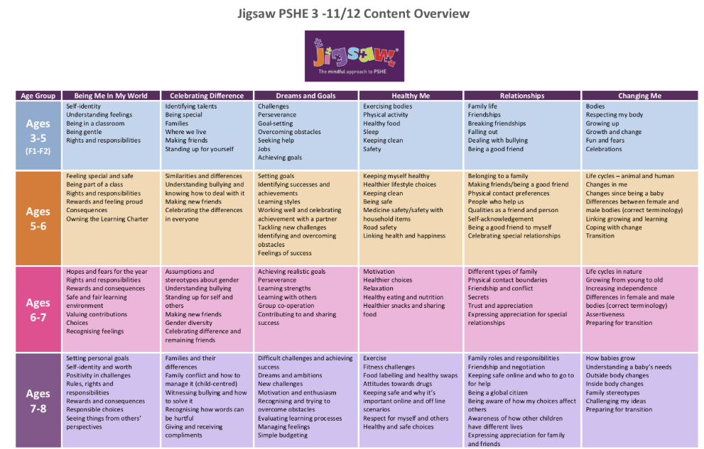

Assessment
In order to identify the needs of our pupils we will be using the Three Houses approach with all our pupils. This will enable us to gather information on all pupils and use a RAG score to identify those most in need of intervention and support.
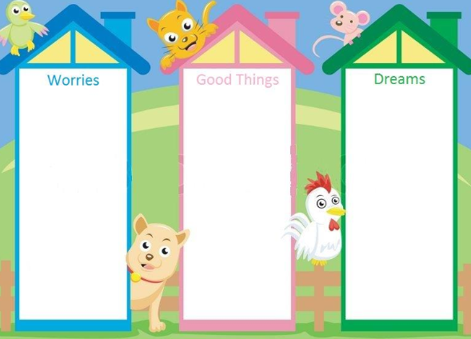


Monitoring
Intervention and impact of planned support will be monitored by the Senior Leadership Team and The Mental Health Lead. Specialist support from Birmingham Education Partnership will support school in auditing existing provision and continuing to move forward.
Staff Development
As a school we will also be introducing Thrive to support the Social, emotional, mental health needs of our pupils. Training for this will begin in the Spring term.
Emotional literacy training will be provided in October 2020 by Beacon Behavior Support.
All staff have access to The National College for CPD development opportunities.

Impact
-Improved whole school attendance
-Class code of conduct created and signed by all children in the class
-Tree of recognition introduced to ensure children can reach gold and have the opportunity to start again if needed after lunch
-Jigsaw curriculum portfolios demonstrate progress through the curriculum
-Improvement in serious behavior incidents recorded

